

HDP oN AWS

Reference Architecture and Deployment Guide

Table of Contents

Abstract 2

Overview 2

Hortonworks Data Platform 2

Amazon Web Services 3

Reference Architecture 6

Deployment Patterns 6

Permanent Clusters 6

Instance selection 7

Storage Options 9

Network Configuration 10

Deployment Guide 10

Ambari 11

Cloudbreak 11

Summary 13

Why Hortonworks for Hadoop? 13

About Hortonworks 13

# Abstract

Business leaders are driving transformational outcomes with new Big Data applications that empower data discovery, a single view of the customer and predictive analytics. The [Hortonworks Data Platform](http://hortonworks.com/hdp/) (HDP) and [Amazon Web Service](https://aws.amazon.com) (AWS), leaders in Open Enterprise Hadoop and Platform As A Service, offer a unique and powerful combination of software and infrastructure services to enable Big Data Applications. This document provides an overview of key technologies, reference architecture and a deployment guide for running HDP on AWS.

# Overview

## Hortonworks Data Platform

Hortonworks Data Platform enables the deployment of Open Enterprise Hadoop – leveraging 100% open source components, driving enterprise readiness requirements and empowering the adoption of brand new innovations that comes out of the Apache Software Foundation and key Apache projects. This comprehensive set of capabilities is aligned to the following functional areas:

* Data Management
* Data Access
* Data Governance and Integration
* Security
* Operations

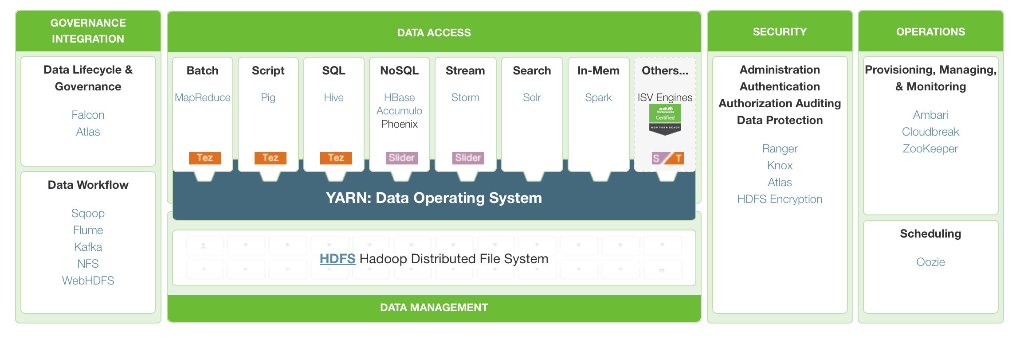

### Data Management

HDFS & YARN: The core of Hadoop

The core components of HDP are Hadoop Distributed File System (HDFS) and YARN. HDFS provides the scalable, fault-tolerant, cost-efficient storage for big data and YARN provides the resource management and pluggable architecture for enabling a wide variety of data access methods. YARN is the architectural center of Hadoop that enables you to process data simultaneously in multiple ways.

### Data Access

Access data from a variety of engines

YARN provides the foundation for a versatile range of processing engines that empower you to interact with the same data in multiple ways, at the same time. This means applications can interact with the data in the best way: from batch to interactive SQL or low latency access with NoSQL. Emerging use cases for data science, search and streaming are also supported with Apache Spark, Solr and Storm. Additionally, ecosystem partners provide even more specialized data access engines for YARN.

### Data Governance and Integration

Load and manage data according to policy

HDP extends data access and management with powerful tools for data governance and integration. They provide a reliable, repeatable, and simple framework for managing the flow of data in and out of Hadoop. This control structure, along with a set of tooling to ease and automate the application of schema or metadata on sources is critical for successful integration of Hadoop into your modern data architecture.

Hortonworks has engineering relationships with all of the data management providers to enable their tools to work and integrate with HDP.

### Security

Authentication, Authorization, & Data Protection

Security is woven and integrated into at HDP in multiple layers. Critical features for authentication, authorization, accountability and data protection are in place so that you can secure HDP across these key requirements. Consistent with approach throughout all of the enterprise Hadoop capabilities, HDP also ensures you can integrate and extend your current security solutions to provide a single, consistent, secure umbrella over your modern data architecture.

### Operations

Provision, manage, monitor and operate Hadoop clusters at scale

Operations teams deploy, monitor and manage a Hadoop cluster within their broader enterprise data ecosystem. HDP delivers a complete set of operational capabilities that provide both visibilities into the health of your cluster as well as tooling to manage configuration and optimize performance across all data access methods. Apache Ambari provides APIs to integrate with existing management systems: for instance Microsoft System Center and Teradata ViewPoint.

## Amazon Web Services

Amazon Web Services provides a complete set of Cloud Computing services that enable you to build sophisticated, scalable solutions. "Cloud Computing", by definition, refers to the on-demand delivery of IT resources and applications via the Internet with pay-as-you-go pricing.

In the next sections we’ll take a look at three core Cloud infrastructure services, provided by AWS, as applicable to deploying HDP – Compute, Network and Storage.

### Amazon EC2

<http://aws.amazon.com/ec2/>

Amazon Elastic Compute Cloud (Amazon EC2) is a web service that provides elastic compute capacity in the cloud. It is designed to make web-scale computing easier for developers.

### Amazon Machine Image

<http://docs.aws.amazon.com/AWSEC2/latest/UserGuide/ec2-instances-and-amis.html>

An Amazon Machine Image (AMI) is a template that contains a software configuration (for example, an operating system, an application server, and applications). From an AMI, you launch an instance, which is a copy of the AMI running as a virtual server in the cloud. You can launch multiple instances of an AMI.

### Instances

<http://docs.aws.amazon.com/AWSEC2/latest/UserGuide/ec2-instances-and-amis.html>

You can launch different types of instances from a single AMI. An instance type essentially determines the hardware of the host computer used for your instance. Each instance type offers different compute and memory capabilities. Select an instance type based on the amount of memory and computing power that you need for the application or software that you plan to run on the instance. After you launch an instance, it looks like a traditional host, and you can interact with it as you would any computer.

### Regions and Availability Zones

<http://docs.aws.amazon.com/AWSEC2/latest/UserGuide/using-regions-availability-zones.html>

Amazon EC2 is hosted in multiple locations world-wide. These locations are composed of regions and Availability Zones. Each region is a separate geographic area. Each region has multiple, isolated locations known as Availability Zones. Amazon EC2 provides you the ability to place resources, such as instances, and data in multiple locations. Resources aren't replicated across regions unless you do so specifically.

Each region is completely independent. Each Availability Zone is isolated, but the Availability Zones in a region are connected through low-latency links. The following diagram illustrates the relationship between regions and Availability Zones.

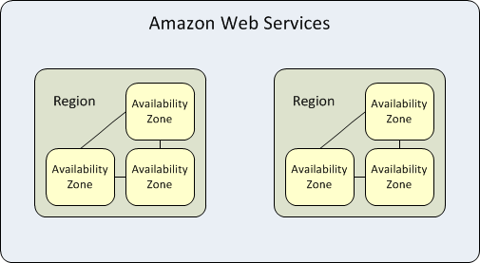

### Placement Groups

<http://docs.aws.amazon.com/AWSEC2/latest/UserGuide/placement-groups.html>

A placement group is a logical grouping of instances within a single Availability Zone. Using placement groups enables applications to participate in a low-latency, 10 Gbps network. Placement groups are recommended for applications that benefit from low network latency, high network throughput, or both. To provide the lowest latency, and the highest packet-per-second network performance for your placement group, choose an instance type that supports enhanced networking.

Placement groups have the following limitations:

* A placement group can't span multiple Availability Zones.
* The name you specify for a placement group must be unique within your AWS account.
* A subset of instance types can be launched within a placement group. Full list of supported instance types can be found here <http://docs.aws.amazon.com/AWSEC2/latest/UserGuide/placement-groups.html>.

### Amazon VPC

<http://docs.aws.amazon.com/AWSEC2/latest/UserGuide/using-vpc.html>

Amazon Virtual Private Cloud (Amazon VPC) enables you to define a virtual network in your own logically isolated area within the Amazon Web Services (AWS) cloud, known as a *virtual private cloud (VPC)*. You can launch your AWS resources, such as instances, into your VPC. Your VPC closely resembles a traditional network that you might operate in your own datacenter, with the benefits of using AWS's scalable infrastructure. You can configure your VPC; you can select its IP address range, create subnets, and configure route tables, network gateways, and security settings. You can connect instances in your VPC to the Internet. You can connect your VPC to your own corporate data center, making the AWS cloud an extension of your datacenter. To protect the resources in each subnet, you can use multiple layers of security, including security groups and network access control lists.

### Security Groups

<http://docs.aws.amazon.com/AWSEC2/latest/UserGuide/using-network-security.html>

A *security group* acts as a virtual firewall that controls the traffic for one or more instances. When you launch an instance, you associate one or more security groups with the instance. You add rules to each security group that allow traffic to or from its associated instances. You can modify the rules for a security group at any time; the new rules are automatically applied to all instances that are associated with the security group. 

### Storage

When it comes to selecting the type of storage to back your instances, there are several choices:

* Instance Stores
* Amazon EBS
* S3

**Instance Stores** provides temporary block-level storage for your instance. This storage is located on disks that are physically attached to the host computer. When an instance is terminated any information in the instance store is lost with it.

**Amazon EBS** provides block level storage volumes for use with EC2 instances. EBS volumes are highly available and reliable storage volumes that can be attached to any running instance that is in the same Availability Zone. EBS volumes that are attached to an EC2 instance are exposed as storage volumes that persist independently from the life of the instance.

**Amazon S3** provides access to reliable, fast, and inexpensive data storage infrastructure. It is designed to make web-scale computing easy by enabling you to store and retrieve any amount of data, at any time, from within Amazon EC2 or anywhere on the web. Amazon S3 stores data objects redundantly on multiple devices across multiple facilities and allows concurrent read or write access to these data objects by many separate clients or application threads. You can use the redundant data stored in Amazon S3 to recover quickly and reliably from instance or application failures.

There are tradeoffs between performance and durability of the information between the different storage types. A key consideration for Big Data applications is “data locality”. At scale, data movement comes with latency and should be factored into the overall architecture.

# Reference Architecture

## Deployment Patterns

HDP on AWS follows two typical deployment patterns:

* Permanent / Long-lived cluster
* Ephemeral / Short lived cluster

Of the two, Permanent cluster is the preferred deployment choice for Hortonworks customers and is the focus of this reference architecture.

## Permanent Clusters

Permanent clusters are available 24x7 and typically run a mix of batch, interactive and real time workloads. Permanent clusters are recommended for organizations establishing Enterprise Data Lake with strict SLA and availability requirements. The physical topology of permanent clusters can follow a mix of “Core” and “Floating” instances, as illustrated below.

Availability Zone

Floating Capacity

Compute

Compute

**Permanent Cluster**

Core Capacity

AWS VPC

Compute & Storage

Compute & Storage

Compute & Storage

Compute & Storage

**Amazon S3**

Cold Storage/Backup

The “Core” instances provide both storage and compute services, while “Floating” instances provide only the compute capacity for the cluster. Hadoop integration with Amazon S3 further allows you to create a tiered storage for your data and a backup zone for your data.

This architecture allows each tier of the infrastructure to scale independently as per your storage and computing needs, and takes advantage of different AWS services to give you the best value from your deployment. In the next section we’ll consider, different options for deploying HDP in terms of instance selection, network configurations and storage options.

## Instance selection

To find the right set of EC2 instances type, it is important to understand characteristic of different node types in Hadoop. Hadoop Nodes can be categorized into

* Master Node
* Worker Node
* Edge Node
* Utility Node

The table below outlines the roles of node types and Hadoop services running within each:

|  |  |  |
| --- | --- | --- |
| **Node Type** | **Description** | **Hadoop Services** |
| Master Nodes | Master Nodes control and manage the cluster resources. | * NameNode * Secondary NameNode * History Server (MR, Spark) * Timeline Server * Resource Manager (YARN) * HBase Master Server * Zookeeper Quorum Nodes |
| Worker Nodes | Worker Nodes are nodes where the work is actually done. These nodes require more CPU and memory resources. | * DataNode * Node Manager (YARN) * HBase Region Server * Solr Server |
| Utility Nodes | Utility Nodes run utility, management or support services for the cluster. | * Journal Nodes * Ambari Server * Oozie Server * Hive MetaStore * HiveServer2 * Hue Server * Falcon Server * hCatalog Server |
| Edge Nodes | Edge Nodes are at the perimeter of your cluster. They provide client access and are leveraged to ingest data into the cluster. | * Hadoop command line client * Hive or command line client * Flume agents * Knox Gateways * 3rd Party Tools |

### Instance Types

The compute, memory and storage resources of instances differ by their node types. Accounting for the different workload needs, the table below provides instance type recommendations for different node types:

|  |  |  |
| --- | --- | --- |
| **Cluster Size** | **Node Type** | **Instance Type** |
| 8-20 Nodes | Master Node | * c3.8xlarge * d2.2xlarge |
| Worker Node | * d2.4xlarge * r3.4xlarge * c3.8xlarge |
| Utility Node | * m3.2xlarge * d2.2xlarge |
| Edge Node | * m3.2xlarge * d2.2xlarge |
| 20-100 Nodes | Master Node | * r3.4xlarge * d2.2xlarge |
| Worker Node | * d2.8xlarge * r3.8xlarge * c3.8xlarge |
| Utility Node | * c3.8xlarge * d2.2xlarge |
| Edge Node | * m3.2xlarge * d2.2xlarge |
| > 100 Nodes | Master Node | * r3.8xlarge |
| Worker Node | * d2.8xlarge * r3.8xlarge * c3.8xlarge |
| Utility Node | * + c3.8xlarge * d2.2xlarge |
| Edge Node | * m3.2xlarge * d2.2xlarge |

Further, for the worker nodes,

* The storage-optimized D2 instances are recommended as the “Core” nodes, since they provide very high sequential read and write access to very large data sets on local storage.
* The memory-optimized R3 instances are recommend as the “Floating” nodes for memory intensive workload like Spark.
* The compute-optimized C3 instances are recommend as the “Floating” for general workloads.

### AMI

Hortonworks Data Platform supports Redhat 6.x, Redhat 7.x, SLES 11 SP3, CentOS 6.x and CentOS 7.x operating systems. Base AMI with one of the supported operating system should be selected. Contingent on availability, HVM AMIs are preferred over PV AMIs.

### Availability Zone & Placement Groups

HDP cluster should reside within a single Availability Zone. Clusters spanning Availability zone are not supported. For best performance, instances should be configured with enhanced networking and placed within the same placement group.

To account for High-availability across multiple Availability Zones, you could use active-active deployment and leverage Apache Falcon for cross-cluster replication. (http://hortonworks.com/blog/introduction-apache-falcon-hadoop/)

## Storage Options

### Data Partition

There are tradeoffs across performance, cost and flexibility between different storage types. . A key consideration for high performance clusters is “data locality”.

Using Instance stores for HDFS, provides better access and faster processing, since the instance stores are physically attached to the host. Although, S3 can serve as the source and destination for Hadoop workloads via s3a and s3n namespace, it has higher latency and lower throughput as compared to HDFS on instance stores.

Finding the right storage depends upon the performance requirements and the characteristics of your workload. Given the current performance profile of different storage types, the usage of Instance Stores as the primary storage and S3 for cold storage is recommended. For reliability and disaster recovery, care must be taken to replicate data across availability zone using the built in capabilities of the Hortonworks Data Platform / cross region replication capabilities of S3.

### OS Partition

For the OS & Log partition, 200-500G of EBS volume is recommended.

## Network Configuration

HDP clusters should be configured with appropriate security groups to maintain information security and optimal network performance. The following network practices are recommended:

### Inbound / Outbound traffic to the cluster

* Enable https access to Ambari Web and Knox Gateway, by opening inbound traffic to port 8443 on the nodes running Ambari and Knox services.
* Enable ssh access to edge node by opening port 22 for inbound traffic
* Enable connection between cluster and S3 by opening outbound traffic to s3.amazonaws.com:8443

### Inter Cluster traffic

It is common of deployments to open the inter-cluster traffic. For environments managing sensitive data such as PII, strict security groups can be set using the service level requirements outlined here http://docs.hortonworks.com/HDPDocuments/HDP2/HDP-2.3.2/bk_HDP_Reference_Guide/content/reference_chap2.html.

# Deployment Guide

There are two main paths you can consider for deploying HDP on AWS:

* Deployment using Ambari
* Deployment using Cloudbreak

## Ambari

Apache Ambari makes Hadoop management simpler by providing capabilities for provisioning, managing, and monitoring Apache Hadoop clusters. Ambari provides an intuitive, easy-to-use Hadoop management web UI backed by its RESTful APIs.

### Deployment Process

Using Ambari, you can easily launch HDP on AWS on cloud in few steps:

1. **Create the infrastructure on AWS**
2. **Deploy Ambari** on one node:
3. **Use Ambari** to deploy HDP:

### Install Instructions

For step-by-step deployment instructions, you can refer to the blog [here](http://docs.hortonworks.com/HDPDocuments/HDP2/HDP-2.3.0/bk_cldbrk_install/bk_cldbrk_instl.pdf) - http://hortonworks.com/blog/deploying-hadoop-cluster-amazon-ec2-hortonworks/

## Cloudbreak

Cloudbreak is a cloud agnostic tool for provisioning, managing and monitoring of on-demand clusters. You can use its scripting to automate tasks and its easy UI to manage services for any configuration.  Cloudbreak can be used to provision HDP in Amazon Web Service. It enables efficient usage of cloud platforms via policy-based auto-scaling that can expand and contract the cluster based on Hadoop usage metrics and defined policies. Additionally, Cloudbreak provides centralized and secure user experience to Hadoop cluster through rich web interface as well as REST API and CLI shell.

### Deployment Process

Cloudbreak is built on the foundation of cloud provider APIs, Apache Ambari, Docker containers, Swarm and Consul. It launches on-demand Hadoop clusters on cloud in 3 steps:

1. **Create Template and provide credential**: A template is an easy way to create and manage a collection of cloud infrastructure related resources, maintaining and updating them in an orderly and predictable fashion. Cloudbreak supports heterogeneous Hadoop clusters by combining different templates. The credential will contain user’s cloud provider specific access information.
2. **Provide Ambari Blueprints**: Ambari Blueprints are a declarative definition of a Hadoop cluster. Blueprints can be either for specialized applications or specific use cases.
3. **Launch Cluster**: In this step, hadoop clusters are launched based on the templates and credentials provided. Once a Hadoop cluster is created and launched, its components can be accessed using the credentials.

Internally, Cloudbreak uses Docker containers to deploy Hadoop clusters and uses [Apache Ambari](http://hortonworks.com/hadoop/ambari/) to have declarative Hadoop cluster with app or use case-specific blueprints, as shown below

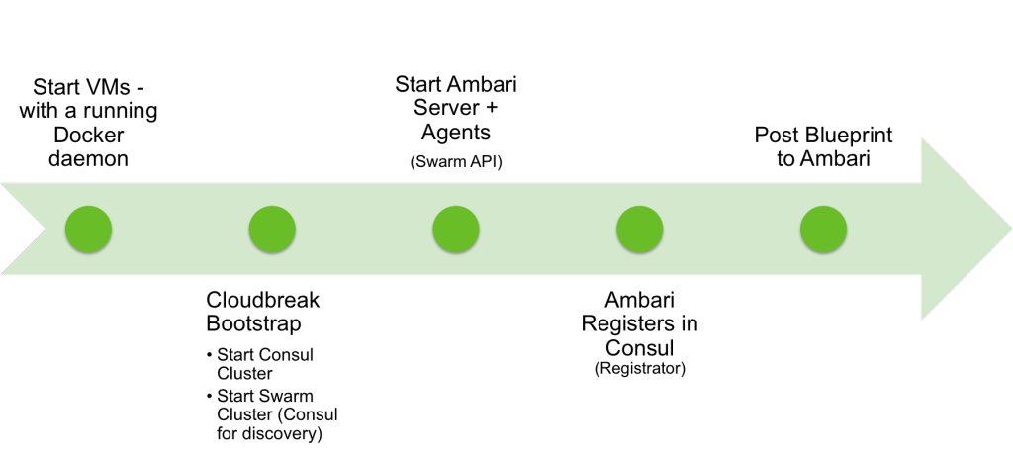

Cloudbreak provides system administrators with the ability to customize HDP network and security cloud provisioning settings using new functionality called Network Resources and Security Group.   Cloud network and security settings can be configured to default or custom levels using these features.

### Auto Scaling

Cloudbreak also optimizes cloud infrastructure usage by providing policy based auto-scaling functionality. These policies can be static time based or can be based on cluster metrics captured by Ambari.

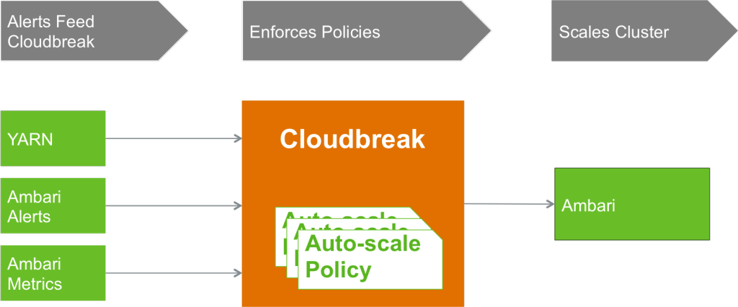

**AUTO-SCALING PROCESS**

### Install Instructions

For step-by-step deployment instructions, please refer to the Clourbreak install and administration guide [here](http://docs.hortonworks.com/HDPDocuments/HDP2/HDP-2.3.0/bk_cldbrk_install/bk_cldbrk_instl.pdf).

# Summary

Being a data driven organization is no longer a choice. Companies that excel in their industries put a high premium on data collection and analytics, allowing them to make faster and smarter decision than their peers. The emergence of connected enterprise along with Apache Hadoop as the cost effective data management and analytics platform, has democratized information insight. Complimenting Hadoop is Amazon Web Services, which makes access to infinitely scalable compute infrastructure accessible to every enterprise. This reference architecture and deployment guide is a joint-effort by Hortonworks and Amazon Web Services to guide our customers in their journey to becoming a Data Driven Organization.

## Why Hortonworks for Hadoop?

Founded in 2011 by 24 engineers from the original Yahoo! Hadoop development and operations team, Hortonworks has amassed more Hadoop experience under one roof than any other organization. Our team members are active participants and leaders in Hadoop development, with proven expertise in designing, building and testing the core of the Hadoop platform. We have years of experience in Hadoop operations and are best suited to support your mission-critical Hadoop project.

For an independent analysis of Hortonworks Data Platform, download the report entitled *Forrester Wave™: Big Data Hadoop Solutions, Q1 2014* from Forrester Research.

## About Hortonworks

Hortonworks develops, distributes and supports a completely open Apache™ Hadoop® data platform. Our team comprises the largest contingent of builders and architects within the Hadoop ecosystem who represent and lead the broader enterprise requirements within these communities. The Hortonworks Data Platform provides an open platform that deeply integrates with existing IT investments upon which enterprises can build and deploy Hadoop-based applications. Hortonworks has deep relationships with the key strategic data center partners that enable our customers to unlock the broadest opportunities from Hadoop. For more information, visit [www.hortonworks.com](http://www.hortonworks.com).